MainACtivity

package com.example.serviceexample;  
  
import androidx.appcompat.app.AppCompatActivity;  
  
import android.content.Intent;  
import android.os.Bundle;  
import android.view.View;  
import android.widget.Button;  
import android.widget.Toast;  
  
public class MainActivity extends AppCompatActivity {  
 Button btnStart, btnStop;  
  
 @Override  
 protected void onCreate(Bundle savedInstanceState) {  
 super.onCreate(savedInstanceState);  
 setContentView(R.layout.*activity_main*);  
 btnStart=findViewById(R.id.*btnStart*);  
 btnStop=findViewById(R.id.*btnStop*);  
 btnStart.setOnClickListener(new View.OnClickListener() {  
 @Override  
 public void onClick(View view) {  
 Toast.*makeText*(getApplicationContext(), "I am within service", Toast.*LENGTH_SHORT*).show();  
 startService(new Intent(MainActivity.this, musicService.class));  
  
 }  
 });  
  
 btnStop.setOnClickListener(new View.OnClickListener() {  
 @Override  
 public void onClick(View view) {  
 stopService(new Intent(MainActivity.this, musicService.class));  
 }  
 });  
 }  
}

musicService.Java

package com.example.serviceexample;  
  
import android.app.Service;  
import android.content.Intent;  
import android.media.MediaPlayer;  
import android.os.IBinder;  
import android.provider.Settings;  
import android.widget.Toast;  
  
import androidx.annotation.Nullable;  
  
public class musicService extends Service {  
 @Nullable  
 MediaPlayer mp;  
 public IBinder onBind(Intent intent) {  
 return null;  
 }  
  
 @Override  
 public int onStartCommand(Intent intent, int flags, int startId) {  
 mp= MediaPlayer.*create*(this,Settings.System.*DEFAULT_ALARM_ALERT_URI*);  
 mp.setLooping(true);  
 mp.start();  
  
 return *START_NOT_STICKY*;  
 *//mp = MediaPlayer.create(this,Settings.System.DEFAULT_RINGTONE_URI);  
 //mp=MediaPlayer.create(this, Settings.System.DEFAULT_RINGTONE_URI);* }  
  
 @Override  
 public void onDestroy() {  
 mp.stop();  
 super.onDestroy();  
  
 }  
}

…………………..

XML………………….

*<?*xml version="1.0" encoding="utf-8"*?>*<LinearLayout  
 xmlns:android="http://schemas.android.com/apk/res/android"  
 xmlns:app="http://schemas.android.com/apk/res-auto"  
 xmlns:tools="http://schemas.android.com/tools"  
 android:layout_width="match_parent"  
 android:layout_height="match_parent"  
 tools:context=".MainActivity">  
  
 <Button  
 android:layout_width="wrap_content"  
 android:layout_height="wrap_content"  
 android:text="Start Service"  
 android:id="@+id/btnStart"/>  
  
 <Button  
 android:layout_width="wrap_content"  
 android:layout_height="wrap_content"  
 android:text="Stop Service"  
 android:id="@+id/btnStop"/>  
  
  
</LinearLayout>

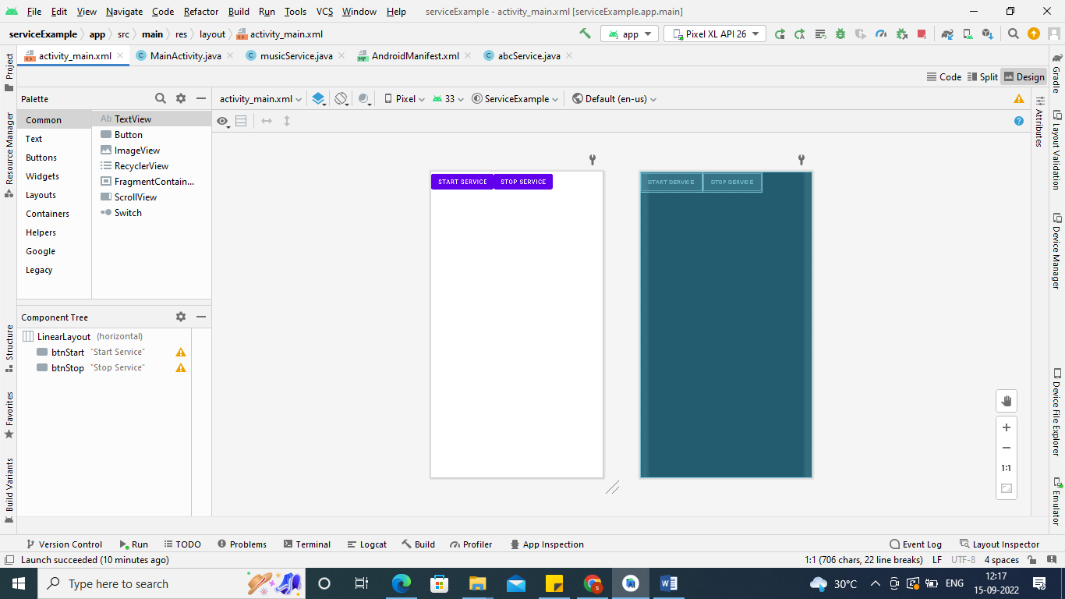

Add this Statement in Manifest File…………

<service android:name=".musicService"/>

…………………………………………………………..